IS3, Ahliah School Lebanon
Our long lasting traditions are to value friends and family and respect your elders and peers at all times. We also share a common interest in marriages because although we have many cultures in South Africa we all believe that when a person in your family is getting married they are not the only ones getting married but the two families are too.
The some ancient images and sounds do support these traditions and try to teach us these things today but most of them sing about what happened during apartheid. The ones that do teach us, teach us to respect everyone and to embrace and care about each other.
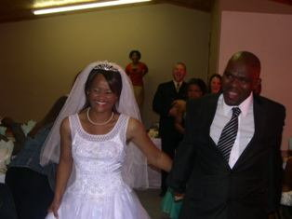
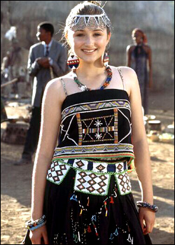

This is a picture of a couple getting married in a white wedding.

This is a picture of a lady attending a wedding in the Zulu culture.

IS4 Tarbalout Daoudi Junior high school, Morocco
The traditional groups in SA are Phuzikhemisi, Ihashe Elimhlophe fall under Umbhaqanga a traditional type of music mostly sang in Zulu. We also have afro jazz singers who are the late Miriam Makeba and Yvonne Chaka Chaka. We also have Reggae singers like the late Lucky Dube. South Africa also has kwaito singers like Brenda Fassie.
These talented people perform in many different festivals for example Randshow and Grahamstown Arts Festivals but they also perform overseas in other countries. They also perform in political gatherings such as elections, inaugurations and party gatherings but they also perform on peoples (famous) birthdays.
They normally have back up dancers but you can always spot them joining in on the fun. They sing songs that inspire, tribute too many legends who existed in their time, teach life experiences, teach about love and they teach us to respect people.
They use many instruments to entertain us such as the western drums, African drums, trumpet, accordion and many more. They dress in different attires such as Xhosa attire, Zulu attire, animal skin and normal close.
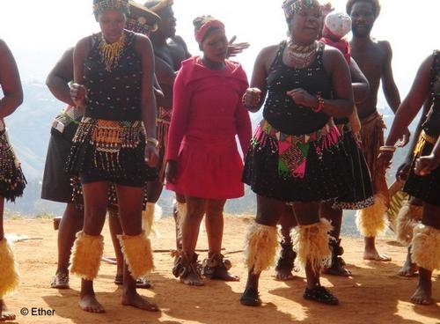
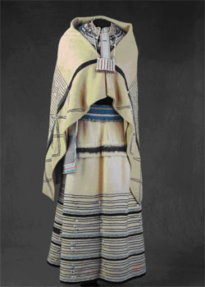

This is a picture of Zulu attire.
This is Xhosa attire.

